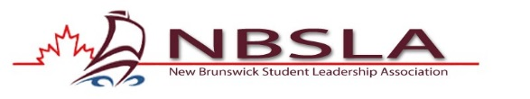
NBSLA Community Outreach Award
The NBSLA Community Outreach Award was developed to recognize schools who are making a significant contribution to their community through their time, talents and dedication.

CRITERIA
The Community Outreach Award recognizes schools who are giving back to their community. Schools are asked to describe their most significant, successful, original community outreach activity accomplished in the 2024-2025 school year. Please submit a description of your activity – its inspirations, management and outcomes in 1-2 typed pages. You are encouraged to include photographs or any other “evidence”. (Such materials may be reclaimed at the conference)

Please submit your most significant/successful/original community outreach activity for the 2024-2025 school year.
No later than November 7th, 2025
To: Marco LeBlanc marco.leblanc@nbed.nb.ca
If electronic format is not possible, mail or fax to:
Marco LeBlanc
c/o John Caldwell School
130 Victoria Street
Grand Falls, NB
E3Z 3B7
Phone: 506-473-7374 Fax: 506-473-7375

Thank you for all you do.
Marco LeBlanc
President NBSLA

